Vpython trace analysis on

MNIST data

1. Dataset MNIST
- Available in torchvision.dataset library
- Is downloaded using this statement:
dataset = datasets.MNIST('data', train=True, download=True, transform=transform)

2. Code
Adapted and modified from these sources:
- https://mlfromscratch.com/neural-network-tutorial/#/
- https://github.com/pytorch/examples/blob/main/mnist/main.py

Some notes:
- Each program uses a certain number images to train. E.g. 10, 20, …, 100, 200, …, 1000, 2000, …, 5000. While a given number of images are used to train and test, all available images are loaded at the beginning of the program.
- Every statement (loading full dataset, defining model, hyper-params, declare model object, etc.) is included in the X except for importing libraries
- There are 60000 images for training and 10000 for testing. However, we used a maximum of 5000 train images for this analysis to keep the simplicity. In addition, the trace prediction result (discussed in section 3 and 4) shows a stable trace outcome (trendline aligns exactly with the real trace + test RMSE is 0) so there’s no need to gather trace from more images than that.
- Only 10 images are used for testing in every program
- Train in 1 epoch. Hyper-parameters are set to either default or popular choice:

- Simple neural network model.
- Model A uses 2 fully connected layers as described below:

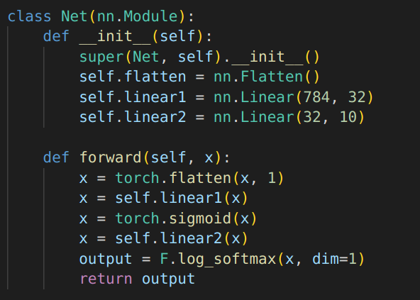

- Model B uses 3 fully connected layers as described below:
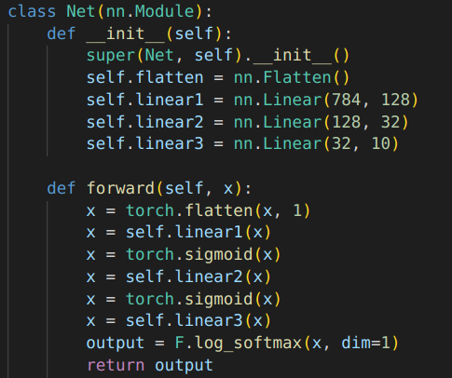

3. Trace analysis result
Trendline plotted aligns exactly with the collected operation numbers
View in GG Sheets (Row 2, 40)

4. Test result
After rounding up the prediction outcome (by a very small fraction, less than 0.001 to be specific), most predictions match very closely with the actual values.
As a result, all RMSE values are nearly 0.
View in GG Sheets (Row 160)
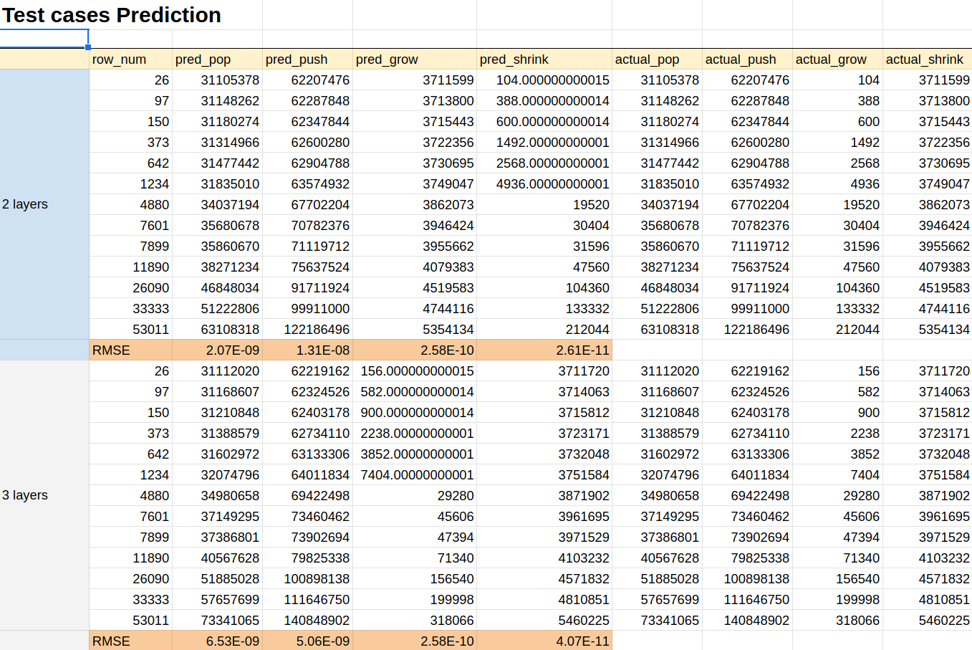
5. Run time comparison
View in GG Sheets (Row 82 – train cases, Row 139 – test cases)
We can say vPython took a lot more time to run the same program. Not to mention >1.1 GB of trace is produced in running each program.

PART 2

